Batch: B1 Roll No.: 1711072

Experiment / assignment / tutorial No. 9

Grade: AA / AB / BB / BC / CC / CD /DD

Signature of the Staff In-charge with date

TITLE: Implementation of RAID levels

AIM: Understanding RAID levels and their importance
_______________________________________________________________
Expected OUTCOME of Experiment:
CO 4-Learn and evaluate memory organization and cache structure
CO 5- Summarize Input output techniques and multiprocessor configurations
__________________________________________________________________
Books/ Journals/ Websites referred:

- Carl Hamacher, Zvonko Vranesic and Safwat Zaky, “Computer Organization”, Fifth Edition, TataMcGraw-Hill.
- William Stallings, “Computer Organization and Architecture: Designing for Performance”, Eighth Edition, Pearson.
3. Dr. M. Usha, T. S. Srikanth, “Computer System Architecture and Organization”, First Edition, Wiley-India.
_____________________________________________________________________

Pre Lab/ Prior Concepts: RAID: Short for Redundant Array of Independent (or Inexpensive) Disks, a category of disk drives that employ two or more drives in combination for fault tolerance and performance. RAID disk drives are used frequently on servers but aren't generally necessary for personal computers. RAID allows you to store the same data redundantly (in multiple paces) in a balanced ay to improve overall performance.
Disk Drives: A machine that reads data from and writes data onto a disk. A disk drive
rotates the disk very fast and has one or more heads that read and write data
Fault Tolerance: The ability of a system to respond gracefully to an unexpected hardware or software failure. There are many levels of fault tolerance, the lowest being the ability to continue operation in the event of a power failure. Many fault-tolerant computer systems mirror all operations -- that is, every operation is performed on two or more duplicate systems, so if one fails the other can take over.
Resources required: Java programming.
Methodology:
RAID 0
.
A RAID 0 (also known as a stripe set or striped volume) splits data evenly across two or more disks (striped) with no parity information for redundancy. It is important to note that RAID 0 was not one of the original RAID levels and provides no data redundancy. RAID 0
is normally used to increase performance, although it can also be used as a way to create a small number of large virtual disks out of a large number of small physical ones. A RAID 0 can be created with disks of differing sizes, but the storage space added to the array by each disk is limited to the size of the smallest disk. For example, if a 120 GB disk is striped together with a 100 GB disk, the size of the array will be 200 GB.

RAID 1
A RAID 1 creates an exact copy (or mirror) of a set of data on two or more disks. This is
useful when read performance or reliability are more important than data storage
capacity such an array can only be as big as the smallest member disk. A classic RAID 1 mirrored pair contains two disks (see diagram), which increases reliability geometrically each member contains a complete copy of the data, and can be addressed independently, ordinary wear-and-tear reliability is raised by the power of the number of self-contained copies.
.
RAID 2
A RAID 2 stripes data at the bit (rather than block) level, and uses a Hamming code for
error correction. The disks are synchronized by the controller to spin in perfect tandem.
Extremely high data transfer rates are possible. This is the only original level of RAID that is not currently used.
The use of the Hamming(7,4) code (four data bits plus three parity bits) also permits using 7 disks in RAID 2, with 4 being used for data storage and 3 being used for error
correction.RAID 2 is the only standard RAID level, other than some implementations of RAID 6,which can automatically recover accurate data from single-bit corruption in data. Other RAID levels can detect single-bit corruption in data, or can sometimes reconstruct missing data, but cannot reliably resolve contradictions between parity bits and data bits without human intervention.
(Multiple-bit corruption is possible though extremely rare. RAID 2 can detect but not repair double-bit corruption.)
At the present time, there are no commercial implementations of RAID 2

Design Steps:
Raid level 0

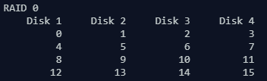

Raid level 1

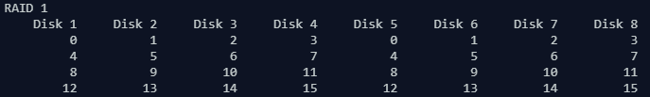

Raid level 2

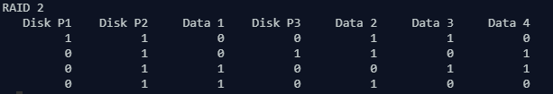

Implementation Details (in Java):

import java.util.*;
class Main {
public static void main(String[] args) {
int code[]=new int[7];
Random rand=new Random();
System.out.println("RAID 0");
System.out.printf("%10s %10s %10s %10s", "Disk 1","Disk 2", "Disk 3","Disk 4");
System.out.println();
for(int i=0;i<16;i+=4){
System.out.format("%10s %10s %10s %10s", i, i+1, i+2, i+3);
System.out.println();
}
System.out.println("RAID 1");
System.out.printf("%10s %10s %10s %10s %10s %10s %10s %10s", "Disk 1","Disk 2", "Disk 3","Disk 4", "Disk 5", "Disk 6", "Disk 7", "Disk 8");
System.out.println();
for(int i=0;i<16;i+=4){
System.out.format("%10s %10s %10s %10s %10s %10s %10s %10s", i, i+1, i+2, i+3, i, i+1, i+2, i+3);
System.out.println();
}
System.out.println("RAID 2");
System.out.printf("%10s %10s %10s %10s %10s %10s %10s", "Disk P1","Disk P2", "Data 1","Disk P3", "Data 2", "Data 3", "Data 4");
System.out.println();
for(int i=0;i<4;i++){
code[4]=rand.nextInt(1000)%2;
code[2]=rand.nextInt(1000)%2;
code[1]=rand.nextInt(1000)%2;
code[0]=rand.nextInt(1000)%2;
code[6]=code[0]^code[2]^code[4];
code[5]=code[0]^code[1]^code[4];
code[3]=code[0]^code[1]^code[2];
System.out.format("%10s %10s %10s %10s %10s %10s %10s", code[0], code[1],code[2], code[3],code[4],code[5],code[6]);
System.out.println();
}
}
}

For verification, my code is available on:
https://repl.it/@ARGHYADEEPDAS/RAIDLevels

Output Screen:

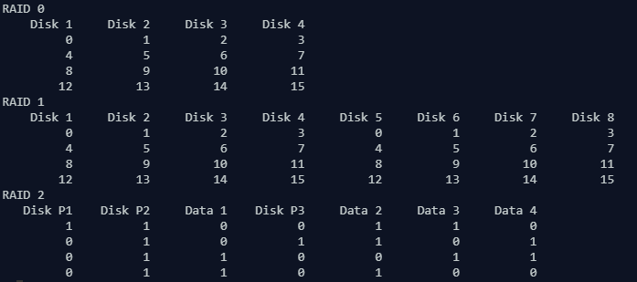

Post Lab Descriptive Questions (Add questions from examination point view)

1. What are the applications of RAID levels? Which level is the most secure?
Ans. RAID (Redundant Array of Inexpensive Disks) is a system developed whereby two or more disks are physically linked together to form a single logical, large capacity storage device that offers a number of advantages over conventional hard disk storage devices:
- superior performance
- improved resiliency
- lower costs
Typically RAID is used in large file servers, transaction of application servers, where data accessibility is critical, and fault tolerance is required. Nowadays, RAID is also being used in desktop systems for CAD, multimedia editing and playback where higher transfer rates are needed.
RAID 6 is the most secure RAID level. It is almost identical to RAID 5 but provides more robust solution.
Conclusion: The program ran successfully as we were able to simulate RAID levels 0, 1 and 2.
Date: 03/10/2018 Signature of faculty in-charge

